TASK 7 S3

Step 1:

Private bucket created and a file has been uploaded. As it is private cant able to see it publicly.

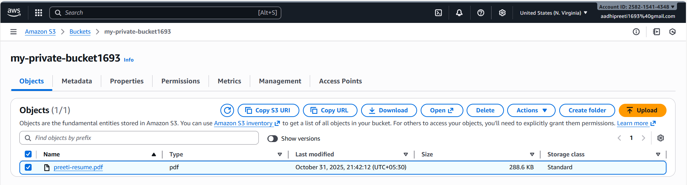

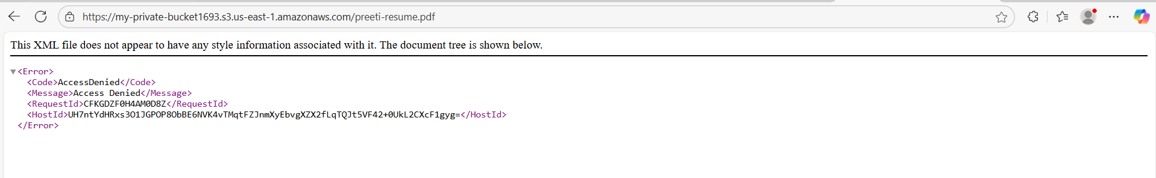

Step 2:

Logs in cloudtrail

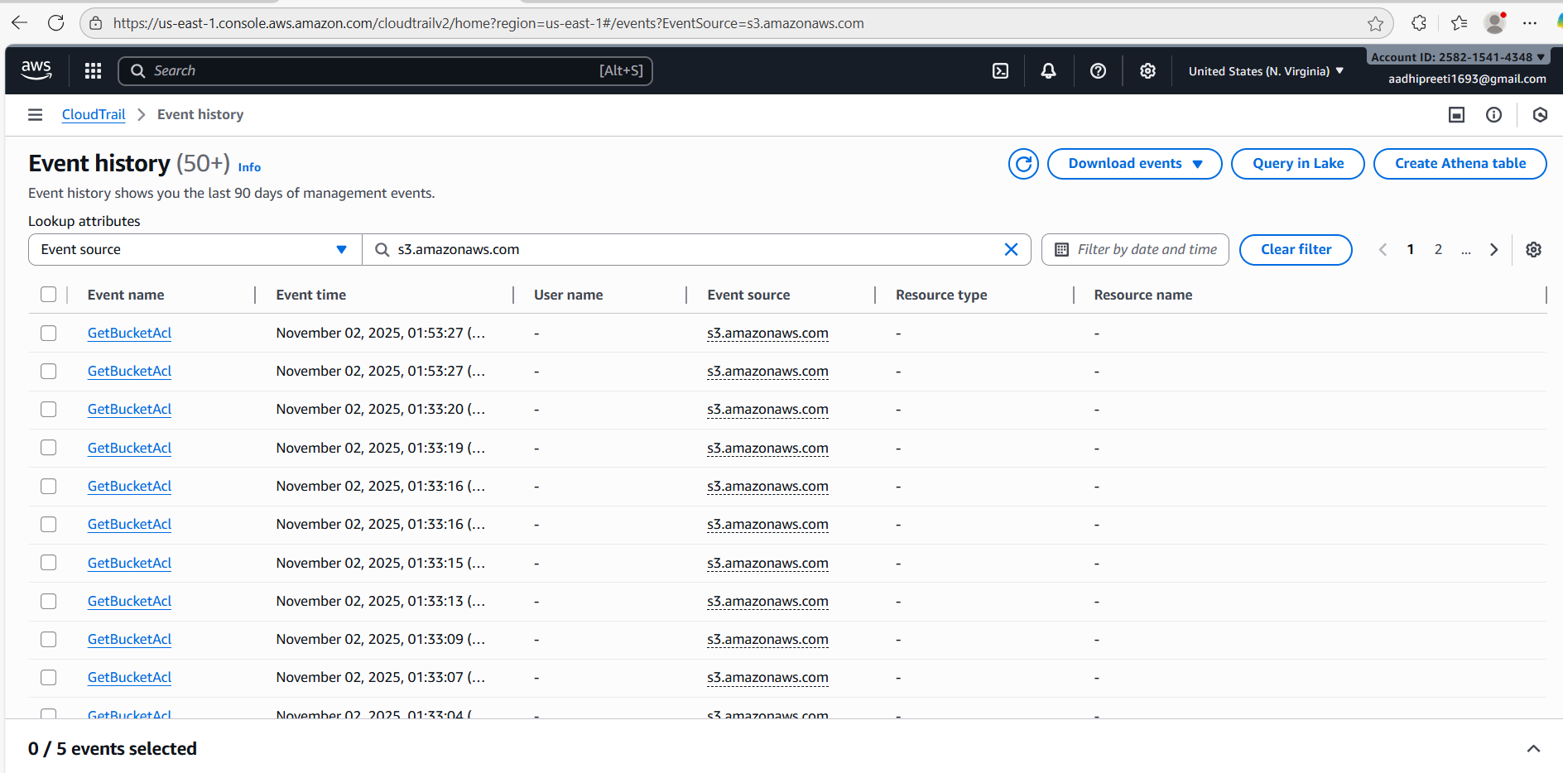

Logs in cloudwatch

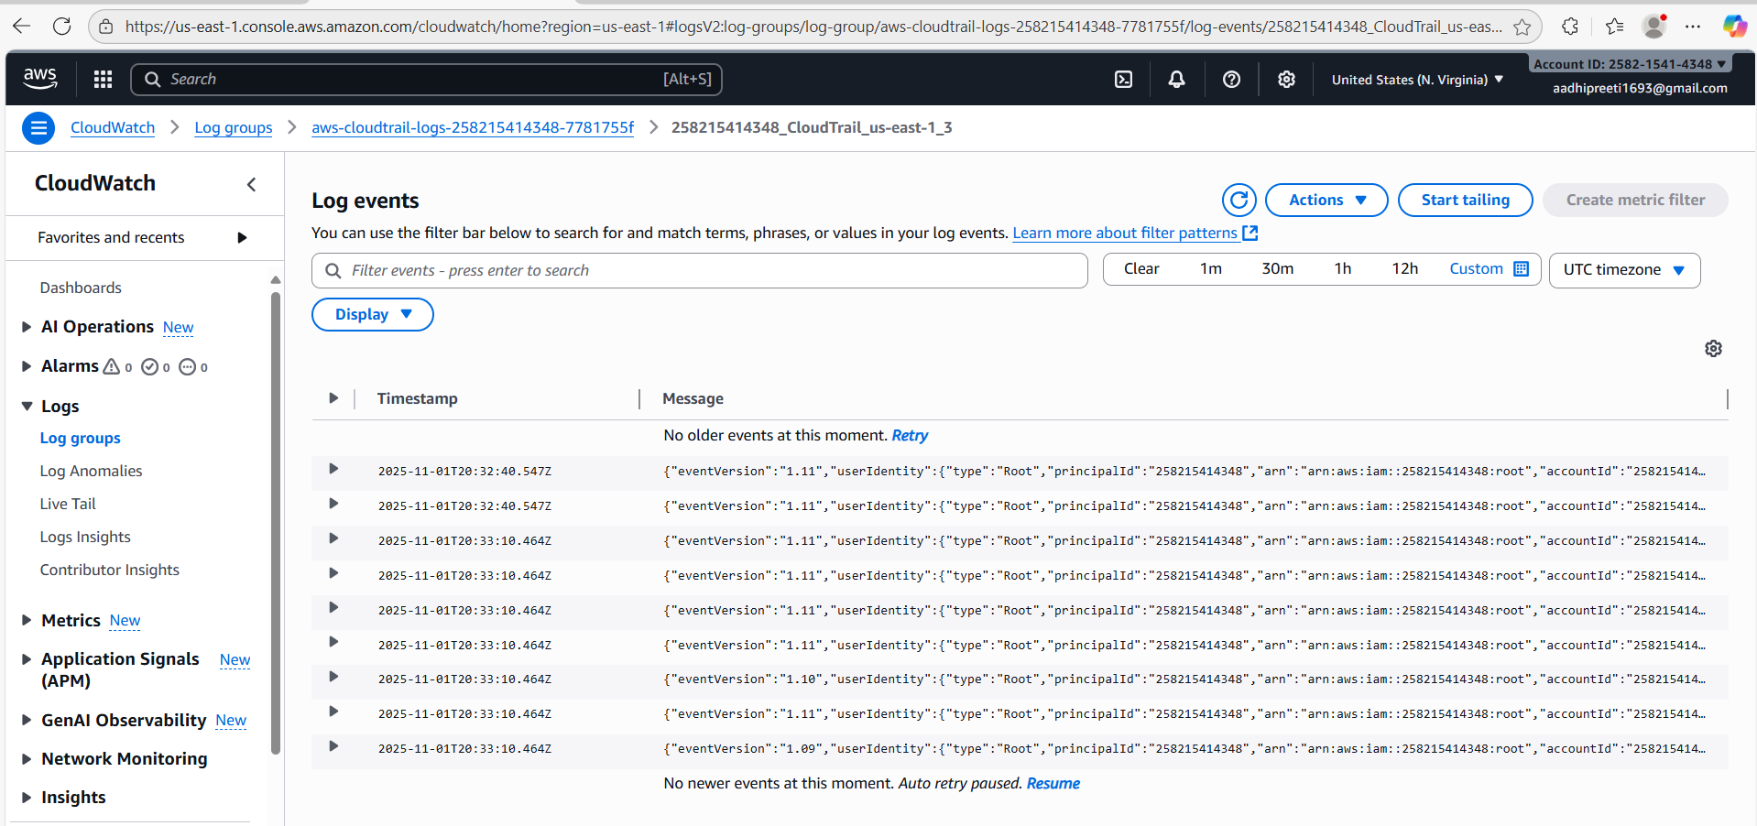

Task 2:

Load Balancer created and its working fine



